DSA0404 - Fundamentals of Data Science
S. SANJAY KUMAR
192324150

Case Study 1 — Detecting an Unusual Customer
A shopping website finds that the average amount spent by customers is ₹2,000, with a standard deviation of ₹400.
A particular customer spends ₹3,200.
- Calculate the customer's z-score.
- Is the customer's spending unusually high compared with the average?
- What would a negative z-score mean in this context?
- If another customer has a z-score of −1.5, what does it tell you?
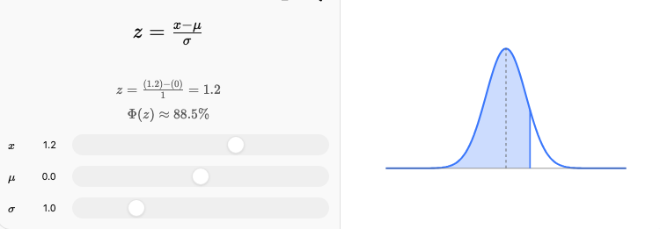
Given: Mean (μ) = ₹2,000, SD (σ) = ₹400, Customer spending (x) = ₹3,200
Z-score formula:
$$z=\frac{x-μ}{σ}$$
Plug in values
$$z=\frac{3200-2000}{400}=\frac{1200}{400}=3$$

Answers:
- Z-score = 3 → the customer's spending is 3 standard deviations above the mean.
- Yes, this is unusually high — a z-score of 3 is far outside the typical range (values beyond ±2 or ±3 are usually considered unusual/outliers).
- A negative z-score would mean the customer spent less than the average customer (below ₹2,000).
- A z-score of −1.5 means that customer spent 1.5 standard deviations below the average — i.e., $2000-1.5\left(400\right)=\text{₹}1,400$, someone who spends noticeably less than typical.

Case Study 2 — Delivery Time Analysis
A delivery company records delivery times (in minutes):
25, 27, 28, 29, 30, 30, 31, 32, 34, 60
- Calculate the mean and median.
- Find Q1 and Q3.
- Calculate the IQR.
- Check for outliers using the 1.5 × IQR rule.
- Explain whether the mean or median gives a better description of the typical delivery time.
ANSWERS:

Data (n=10): 25, 27, 28, 29, 30, 30, 31, 32, 34, 60
1. Calculating Mean and Median
Mean
$$\text{Sum}=25+27+28+29+30+30+31+32+34+60=326 \\ \text{Mean}=326/10=32.6\text{ minutes}$$
Median
Data already sorted, n=10 (even) → average of 5th and 6th values
$$5^{th}=30, 6^{th}=30⇒\text{Median}=30$$
2. Finding Q1 and Q3
- Lower half (first 5 values): 25, 27, 28, 29, 30 → Q1 = 28
- Upper half (last 5 values): 30, 31, 32, 34, 60 → Q3 = 32
3. Calculating IQR
$$IQR=Q3-Q1=32-28=4$$
4. Outlier check (1.5×IQR rule)
$$\text{Lower bound}=Q1-1.5\left(IQR\right)=28-6=22 \\ \text{Upper bound}=Q3+1.5\left(IQR\right)=32+6=38$$
Any value < 22 or > 38 is an outlier → 60 is an outlier (no values below 22).
5. Mean vs Median
Mean (32.6) is pulled upward by the outlier (60), while the median (30) is unaffected by extreme values. The median better represents the typical delivery time.

Case Study 3 — Two Cities' Temperatures
The average daily temperatures (°C) for 7 days are:
City A: 28, 29, 30, 30, 31, 30, 32
City B: 20, 25, 30, 35, 30, 25, 45
- Calculate the mean temperature for each city.
- Calculate the variance for each city.
- Which city has greater temperature variability?
- Why can two datasets have the same mean but different standard deviations?
- Which city has more predictable temperatures?
Answers:
1. Mean temperature of each city
$$\text{City A Sum}=28+29+30+30+31+30+32=210⇒{\text{Mean}}_{A}=210/7=30 \\ \text{City B Sum}=20+25+30+35+30+25+45=210⇒{\text{Mean}}_{B}=210/7=30$$
Both cities have the same mean (30°C).
2. Variance of City A
Deviations squared from mean (30):
Value | Deviation | Squared
28 | -2 | 4
29 | -1 | 1
30 | 0 | 0
30 | 0 | 0
31 | 1 | 1
30 | 0 | 0
32 | 2 | 4
Sum of squares = 10
$${\text{Variance}}_{A}=10/7≈1.43 \\ {\text{SD}}_{A}=\sqrt{1.43}≈1.20$$

Variance of City B
Value | Deviation | Squared
20 | -10 | 100
25 | -5 | 25
30 | 0 | 0
35 | 5 | 25
30 | 0 | 0
25 | -5 | 25
45 | 15 | 225
Sum of squares = 400
$${\text{Variance}}_{B}=400/7≈57.14 \\ {\text{SD}}_{B}=\sqrt{57.14}≈7.56$$
3. City B has far greater variability (variance ≈57.14 vs ≈1.43).
4. Two datasets can share a mean but differ in SD because the mean only reflects the center, not how spread out the individual values are around it — City B's values swing much further from 30 than City A's.
5. City A has more predictable temperatures (lower SD → values stay consistently close to the mean).

Case Study 4 — Data Center CPU Usage
A data scientist records CPU usage percentages:
40, 42, 45, 45, 46, 48, 50, 52, 55, 90
- Calculate mean, median, and mode.
- Calculate the range.
- Find Q1, Q3 and IQR.
- Identify possible outliers.
- Determine the direction of skewness.
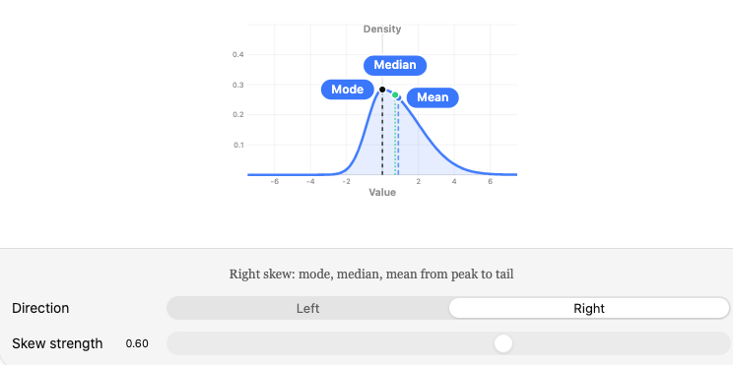

Answers:
Data (n=10): 40, 42, 45, 45, 46, 48, 50, 52, 55, 90
1. Mean
$$\text{Sum}=40+42+45+45+46+48+50+52+55+90=513 \\ \text{Mean}=513/10=51.3$$
Mediann=10, average of 5th and 6th values: 46 and 48
$$\text{Median}=\left(46+48\right)/2=47$$
Mode
45 appears twice — all others appear once → Mode = 45
2. Range
$$\text{Range}=90-40=50$$
3. Q1 and Q3
- Lower half (first 5): 40, 42, 45, 45, 46 → Q1 = 45
- Upper half (last 5): 48, 50, 52, 55, 90 → Q3 = 52
$$IQR=52-45=7$$
4. Outlier check
$$\text{Lower bound}=45-1.5\left(7\right)=34.5 \\ \text{Upper bound}=52+1.5\left(7\right)=62.5$$
90 exceeds 62.5 → it's an outlier.
5. Skewness
Since Mean (51.3) > Median (47), the data is right-skewed (positive skew) — the high outlier (90) pulls the mean upward relative to the median.

Case Study 5 — Comparing Two Datasets
Two data analysts receive the following datasets:
Dataset A: 10, 20, 30, 40, 50
Dataset B: 28, 29, 30, 31, 32
- Calculate the mean of both datasets.
- Calculate the variance of both.
- Calculate the standard deviation of both.
- Which dataset has greater spread?
- If both datasets represent model errors, which model appears more consistent?
- Explain why mean alone is not enough to compare datasets.
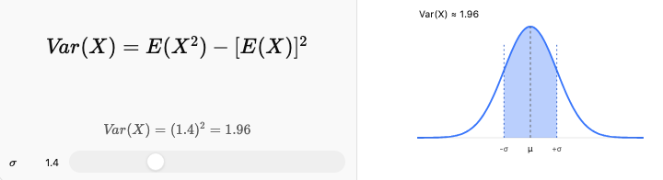

Answers:
1. Mean of both
$${\text{Mean}}_{A}=\left(10+20+30+40+50\right)/5=150/5=30 \\ {\text{Mean}}_{B}=\left(28+29+30+31+32\right)/5=150/5=30$$
Both datasets have the same mean (30).

2. Variance of Dataset A
Deviations squared from 30: (10-30)²=400, (20-30)²=100, (30-30)²=0, (40-30)²=100, (50-30)²=400
Sum = 1000
$${\text{Variance}}_{A}=1000/5=200 \\ {\text{SD}}_{A}=\sqrt{200}≈14.14$$
Variance of Dataset B
Deviations squared from 30: (28-30)²=4, (29-30)²=1, (30-30)²=0, (31-30)²=1, (32-30)²=4
Sum = 10
$${\text{Variance}}_{B}=10/5=2 \\ {\text{SD}}_{B}=\sqrt{2}≈1.41$$
3. Dataset A has much greater spread (SD ≈14.14 vs ≈1.41).
4. If both represent model errors, Model B (Dataset B) appears more consistent, since its errors are tightly clustered near the mean, even though the average error is identical to Model A's.
5. Mean alone isn't enough because two datasets can have an identical mean while behaving very differently - Dataset A's values are widely scattered while Dataset B's are tightly packed. Only variance/SD reveals this difference in reliability/consistency.

